THAMESFORD MINOR BASEBALL ASSOCIATION

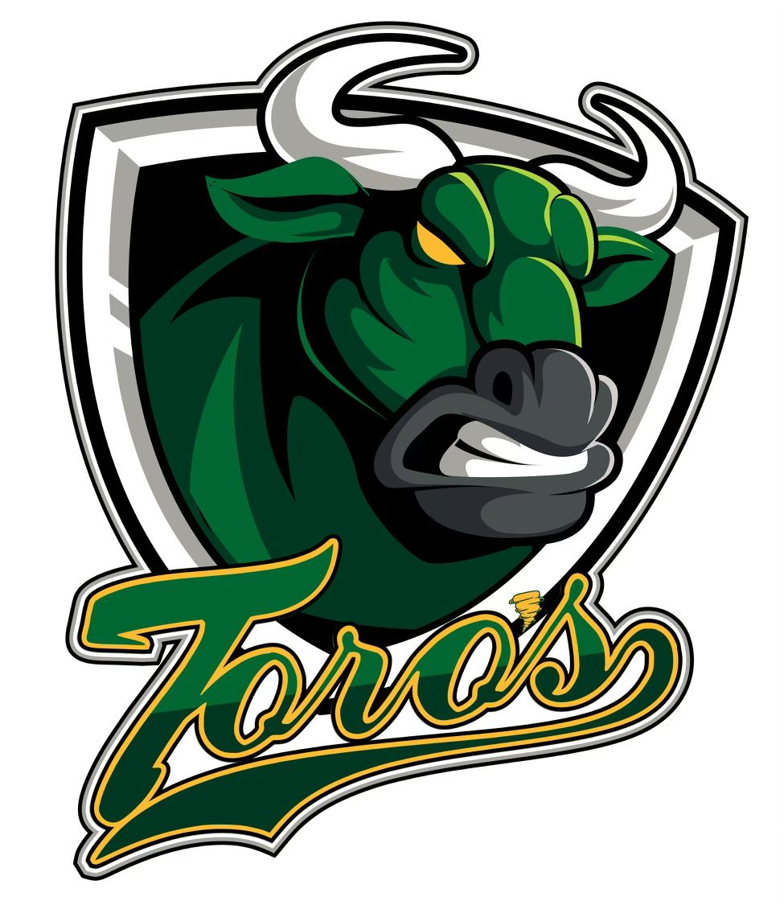

2024
SPONSORSHIP PACKAGE

To Whom It May Concern:

The mission of the Thamesford Minor Baseball Association is to provide children, of all ages, the opportunity to learn and play the game of baseball in a friendly and welcoming environment. Baseball teaches children self confidence, discipline, team work and good citizenship, while promoting healthy living.
The Thamesford Minor Baseball Association was established in 1978. We are members in good standing with the Ontario Minor Baseball Association (OBA). Our organization is administered exclusively by volunteers. The Board of Directors of Thamesford Minor Baseball Association is dedicated to providing the youth of the Thamesford area with the best baseball experience possible.

While our Association has excellent commitment through the parents and volunteers, we must rely on outside sources to sustain our quality programs. Sponsorship has always played a vital role in the development of our minor baseball program and we are very grateful to all the sponsors that have, and continue to be involved with the Thamesford Minor Baseball Association.

As a business owner and member of our community, we would like to extend an invitation for you to sponsor TMBA and/or one of our teams. Your contributions will be beneficial to ensuring that the Thamesford Minor Baseball Association can continue to offer excellent baseball programs for our youth in the Thamesford area.

WHY SPONSOR TMBA Baseball?

- Our baseball diamonds in Thamesford is filled with players, parents, siblings, grandparents and baseball fans of Thamesford Minor Baseball, in addition to visiting associations, offering great exposure to your business.

- Our website gets significant daily traffic and your link can be on it. Our website gets approximately 35,000 visits per year. As a sponsor your organization will benefit from this exposure.

- We actively encourage our membership to support our sponsors especially during these difficult times and promote – Shop Local.

- Our teams play games in neighboring communities such as London, Dorchester and Thorndale; your sponsor bar will be proudly displayed.

HOW DOES YOUR SPONSORSHIP HELP?

- Sponsorship revenue helps to keep registration costs affordable so that more children are able to participate and enjoy the game of baseball.
- Allows TMBA to provide the best skill development for coaches and instructors.
- Ensures players of all ages and abilities are provided with opportunities to excel.
- Fosters community involvement and partnership.
- Provides funding for the purchase of uniforms and baseball equipment.
- Supports the day to day operation of our minor baseball association.

We look forward to your support and thank you very much for your anticipated assistance. Additionally, we would welcome the opportunity to discuss any other sponsorship ideas that you may have to help sponsor the youth of the Thamesford area who play minor baseball. For more information and to share your sponsorship ideas, please contact our Sponsorship Coordinator, Kathy McLachlan via email at mclachlans219@gmail.com

TMBA has introduced some exciting new programs which offer our sponsors many value added features with the goal of increased exposure to you and your customers while supporting our association. Please see the attached sponsorship options.

TMBA Sponsorship Tiers

If you would like to be a sponsor please complete the attached sponsorship form. Thank you in advance for supporting the Thamesford Minor Baseball Association. There are a variety of options:

- $450 - Team Sponsor*
You will receive the following:
- Your Company name shown on a Sponsor Bar on the back of one set of team jerseys
- Listed as a sponsor on the TMBA website with your Company Logo and a link to your website
- Thank You note posted on TMBA’s Facebook page

- $400 – Sponsorship Board @ North Park
You will receive the following:
- Sponsorship board with business name and logo (6ft x 3 ft) displayed on the outfield fence at North Park for onetime cost of $400. Renewal fee of $100 each year thereafter.
- Listed as a sponsor on the TMBA website with your Company Logo and a link to your website
- Thank You note posted on TMBA’s Facebook page

- $800 – Team Sponsor** + Sponsorship Board @ North Park
Sponsorship would include sponsor bar as well as sponsorship board (option 1 and 2)
- Listed as a sponsor on the TMBA website with your Company Logo and a link to your website
- Thank You note posted on TMBA’s Facebook page

- $100 - Company Logo on TMBA Website
You will receive the following:
- Listed as a sponsor on the TMBA website with your Company Logo shown and a link to your website
- Thank You note posted on TMBA’s Facebook page

*Team sponsor availability is limited to the number of teams registered each season. Opportunities are based on availability.

THAMESFORD MINOR BASEBALL ASSOCIATION
2024 SPONSORSHIP FORM

Company Name: __________________________________________________________________________
Address:_________________________________________________________________________________
City:________________________________ Postal Code:____________________
Telephone:_________________________Email:_________________________________________________
Company Web Site Address:_________________________________________________________________
Contact Person:___________________________________________________________________________
PLEASE CHOOSE LEVEL OF SPONSORSHIP:

____ Option 1: $450
____ Option 2: $400
____ Option 3: $800
____ Option 4: $100

Return completed form and payment as follows:
By Mail or Drop off to: TMBA c/o Kathy McLachlan PO Box 407, Thamesford, ON N0M 2M0
mclachlans219@gmail.com

CHEQUES TO BE MADE PAYABLE TO: THAMESFORD MINOR BASEBALL ASSOCIATION or TMBA

- Sponsorship letters will be provided upon request

THANK YOU FOR SPONSORING THE YOUTH OF THE THAMESFORD MINOR BASEBALL ASSOCIATION

